HT Report – Parent Partnership AGM Sept 2020

There has never been a school year quite like this one. I continue to be immensely proud of the work of my team throughout what has turned out to be a very different school session. As the world becomes increasingly interconnected, so do the risks we face. The COVID-19 pandemic has not stopped at borders or individual homes and communities. It has affected people regardless of nationality, level of education, income or gender. But the same has not been true for its consequences, which in some ways have hit the most vulnerable families the hardest. We have certainly seen this within our school community.
Pupils from some homes and backgrounds, often those who are well supported by their parents and eager and able to learn, could find their way past closed school doors to alternative learning opportunities and able to maximise the home learning on offer from teachers. Those from disadvantaged backgrounds or difficult home environments often remained shut out when their schools shut down. My staff worked throughout lockdown supporting a variety of learners through the provision of home learning but also support our most vulnerable pupils within St Paul’s hub. This was a life-line for many families and meant school staff could check on children’s wellbeing and support our most vulnerable families. The numbers we could invite were limited and I know that we could have filled the places on offer several times over. We know that resilience research frequently cites teachers and school staff as trusted significant adults and positive role models for children and young people. Teachers have the skills needed to support children and young people through difficult times, to help inspire their resiliency and hope and to help them recover their wholeness and find comfort in their community. But I see the impact of this exhausting work on my team – they are already tired, many having given up their Easter and Summer breaks to volunteer within hubs, as well as home schooling their own children or caring for their own family members.
This crisis has exposed the many inadequacies and inequities in our education systems – from access to the broadband and computers needed for online education, and the supportive environments needed to focus on learning, up to the misalignment between resources and needs. We did our best to ensure that we could support everyone who needed help, through the provision of stationery, paper HW as well as referrals to agencies and hub places to the creation of our ‘special support team’ – Kirsten, Stacey, Phillipa P2B and Yvonne Miliken to support families in need, as well as our strong links with Downfield Mains. A huge challenge for some staff was technology capability, but all showed great resolve and a commitment to do the best for our families and I wish to take this opportunity to say well done to them all. With very little training and support they did a truly fantastic job.
Managing and leading through this time of great complexity has been a huge responsibility, especially when we acknowledge that many adults in the school community will also be experiencing a similar range of emotions and reactions as the children, young people and their families. Experiences of bereavement and loss, caring for someone shielding, living with a frontline NHS worker or carer, coping with additional stressors, worry and anxiety will be shared and lived experiences for many. At this point I would like to pay special mention to the extended leadership team – Fiona, jill, Stuart and Laura. They all played a blinder through the situation and truly demonstrated team-work and commitment to our school.

The lockdowns in response to COVID-19 have interrupted conventional schooling nationwide. Teachers also had to adapt to new pedagogical concepts and modes of delivery of teaching, for which they may not have been trained. Many of the approaches we are now forming are reminiscent of learning and teaching when I first became a teacher 25 years ago. Learners in the most marginalised groups, who don’t have access to digital learning resources or lack the resilience and engagement to learn on their own, are undoubtedly at risk of falling behind. We are only beginning to become fully aware of the impact of the last few months on our pupils and as a team are focusing our efforts on some key issues within our school improvement plan to help should this happen again, with a big push on developing our school capability in terms of digital learning.
During the pandemic, remote learning became a lifeline for education but the opportunities that digital technologies offer go well beyond a stopgap solution we pulled together during the crisis. Digital technology offers entirely new answers to the question of what people learn, how they learn, and where and when they learn. This applied to our staff for meetings and staff development too. Technology can enable teachers and students to access specialised materials well beyond textbooks, in multiple formats and in ways that can bridge time and distance. We are looking forward to working as a team this year to support Downfield ‘s digital journey even further, and this is something we would like to heavily involve our parents and school community in. We would like to invite our parents to join us on this journey and learn with us.
Disasters, emergencies or indeed pandemics throw light on the world as it is. Some thinkers who study disasters frame crises not just in terms of what is lost but also what might be gained – seeing glimmers of possibility. Every disaster is different and it’s never just one or the other: loss and gain always coexist….and there have certainly been some positives amongst all of this! Some of the Covid plans we have put in place have been seen as being better than what happened before, with parents, staff and children saying they like some aspects of the ‘new norm’ better. There will be bits of what we have changed that we will keep, but bits we are most definitely look forward to getting back to what we did before.

As much as returning to school may feel like a relief, or even feel exciting for some children and young people, it is also likely to be a time when many children and young people feel anxious, particularly those who have underlying health conditions or who live with someone who is shielding. Feeling safe may have come to be associated with ‘staying at home’, ‘social distancing’ and frequent handwashing and so we all need to learn new ways to continue to feel safe whilst connecting with our friends and peers and learning together back in our school setting. Teachers are helping to create classroom environments that provide reassurance, for example, how they are following the latest government and scientific guidelines, and make expectations clear about how we can all look after ourselves and each other. This takes time and it is important for us to hold on to the idea of a transition period as we develop new ways of learning together in the aftermath, rather than rushing or putting unnecessary pressure on ourselves or each other to ‘feel or get back to normal’. My team are aware that some children are struggling, particularly a number of our younger learners across P1 and P2. We see this through children struggling with behaviour, coping with firmer routines, lockdown magnified tricky home situations for some, we have seen spikes in child protection issues and referrals, families sharing financial hardships and poverty, some children having fallen behind in terms of academic progress and some children had not been able to engage in home learning at all during lockdown.
Some of our children and young people need to be aware that their behaviour has consequences however what they require is lots of patient teaching, reminders and clear boundaries and expectations that are repeatedly explained in different ways and enforced consistently. This has however provided challenges for us during term 1. Some children returned to school in a good place, ready to learn and ready to reconnect with peers and staff whilst a small number are requiring high levels of support and we are not yet fully staffed in terms of support hours. The current crisis has really tested our ability to deal with large-scale disruptions – I don’t think we’ve done too badly at all and I’d like to thank our parent body for their patience, support and encouragement throughout. It has been very much appreciated by the team.

Last year we made good progress through our SIP –
- Embed L & T approaches – Lit, num, HITS, Nurture, SALT (E)
- Develop the wider curriculum experiences for the children including trips (O)
- Fully roll out mindfulness approaches for all children (S)
- Use of PEF – additional staffing (SFL/Support), dev sensory room, targeted approaches for lit/num for some children, Place 2 Be Counselling (S,P,M, I), ATTENDANCE
- Broadening out of our Nurture approaches and outdoor learning for more children
- Wider curricular experiences - CIT GRPS LIST P1 / 2 Kodaly, P3/4 big sing/intergenerational, P5 SFA Football & Swimming, P6 Samba drumming & Swimming, P7 Residential experience Sept.
- Sharing the learning events to continue and higher levels of parental involvement in life of school – difference in reporting to parents SEEMIS/Bi-annual Reports
- Continue to build the positive working relationship between school and parent partnership, with a focus on outdoor spaces

This year’s improvement plan has a focus on school recovery, and particularly this term on 3 main things …. Re-connect/relationships – Re-engage – with learning and routines and Regulation – time to process what has happened and is happening and to work on ourselves and remaining calm/positive wellbeing.
We have created a very focused School Improvement Plan, further enhanced by our Pupil Equity Funding projects. The draft plan is attached at the end of this report. The main focus of this year’s plan is:
1. high-quality teaching for all, revisit and revise pedagogy HITS – nothing new but doing what we do in a different way!
2. targeted academic support - Nurturing approaches, interventions that work Lit/Num/Soc for those who need it.
3. wider strategies to support pupils in the year ahead – widen universal nurture approaches, consistent 6 and visualised environment, invest time in developing digital skills for all – pupils, parents, staff and our 3 R recovery plan.

Last year we continued to invite parents into school for ‘sharing the learning’ and parent contact, offering parents a wide variety of opportunities to come in and see what and how the pupils are learning. We also were part of a reporting to parents pilot which will continue this year. Our sharing the learning events and parent contact evening as always, are well-attended – a great indicator, we hope, of a continuing growth in confidence in the school and the improving level of parental partnership we enjoy here at Downfield. Things will need to look very different this school session, and welcome suggestions and thoughts from parents and carers about how we may do this differently in the current climate and given the constraints we have for infection control.
I would like to take this opportunity to personally thank all the parents from PP, parents and carers for their help and support last year and moving forward. Many hours have been spent planning for contingencies and support that often weren’t needed, this time spent has meant that things are a little behind where they would normally be at this time……I have to admit that this is stressful for me! I continue to enjoy my role here and am proud to be head teacher of this amazing school. An aspect of my role I love is the people – our school community – the kids, parents and team and fantastic and I wouldn’t change them for the world. Downfield is a dynamic school, with a widely diverse catchment and an unmistakeable buzz. We undoubtedly have our challenges to embrace, but we are a school of high ambition and my aspiration for us is that we will grow and develop into a sector leading and highly effective school. Partnership with parents and our community is an important aspect of the Downfield Promise, and this will continue to be key to us achieving our ambitious aspirations and goals in the coming session.

Downfield Primary School

Our vision at Downfield is for our school community to live by our PROMISE.
COVID Recovery & Improvement Plan
Our recovery plan to support children back to school and learning following the COVID crisis will focus on three key areas.
Re-connect Regulation Re-engagement

Reconnect as a school community: Relationships
Relationships are key to our children and families feeling safe and secure in school. There will be an early focus on reconnections with maximum opportunities for communication and dialogue with children and families in order to build relationships and resilience.
Staff will be refocusing on our behaviour and learning blueprints to increase their skills and knowledge of how to build relationships, a positive school ethos and improve pupil’s resilience through engaging activities and quality dialogue, where all learners will have a clear voice. Our school promise and nurturing approaches will be key to building positive connections with all. Focus on our Paul Dix work from 2018 – Meet and greets, recognition boards etc.
Regulation – being calm and staying calm
Supporting the physical, mental, social and emotional wellbeing of our families and staff will be a priority. Good health and wellbeing is fundamental in ensuring that children can engage effectively in their learning and staff feel empowered to support our pupils who may be experiencing a range of emotions.
It will be important to share our experiences during lockdown and offer compassion and individual support as required. A key focus will be supporting children to regulate their emotions and express them in a safe and appropriate manner. Staff’s understanding of the nurturing principles and practices is fundamental in supporting this.
Nurture is important for wellbeing and self-esteem and promotes inclusive, respectful relationships across the whole school community. A nurturing approach is based on the understanding of the 6 Nurturing Principles which are:-
- NP1: Children’s learning is understood developmentally.
- NP2: The classroom/environment offers a safe base.
- NP3: The importance of nurture for the development of wellbeing
- NP4: Language is a vital means of communication
- NP5: All behaviour is communication
- NP6: Transitions are important in children’s lives
We will have an increased focus on the ‘Consistent Six’ which is underpinned by the nurture principles. The ‘Consistent Six’ is a cluster approach to supporting all children. They set clear and consistent expectations and boundaries in line with our Vision, Values and Aims both at a universal and targeted level. The ‘Consistent Six’ are:-
‘Consistent 6’
(universal across all classrooms)

Emotional Check-in and meet and greet
Safe spaces in rooms
Visuals on lanyards and visual day schedule
Restorative questions
5 pt regulation scale
Give me 5 for attention and listening rules

‘Consistent 6’
(targeted supports)

Visual schedules - individuals
‘I need’ boards
Fix it folders
Calm sequences/kits
Target boards - tracking targets in Able plans in a visual way
First and Then strips and scripts

The pupils will also be taught a range of calm strategies such as breathing techniques and thinking of a happy place to support emotional regulation.

We will re-engage children with our whole school approaches of mindfulness, ‘chill and still’, and our mantra ‘in our school we treat each other with kindness and respect.’
Re-engagement- with learning, our promise and routines
At Downfield Primary School, we will put learners at the heart of education by focussing on the four capacities. We want all our learners to be Successful Learners, Responsible Citizens, Effective Contributors and Confident Individuals. In order to do this we will provide a curriculum which is adaptable and responsive to the needs of individual learners.
There will be an enhanced focus on outdoor and play based learning approaches, including opportunities for physical activity and time to relax. Learning will be chunked into smaller segments with regular breaks built in whilst our children build the resilience required for learning,
Continued partnership with Ancrum Outdoor, P2B and a range of partners will enrich learning experiences, build resilience and provide targeted support where required.
There will be an initial focus on providing high quality learning experiences in Literacy, Numeracy and Health and Wellbeing, extending to motivating Interdisciplinary Learning (IDL) providing experiences across the Broad General Education (BGE). We will thoughtfully consider how to provide additional and appropriate support where it is most needed to maximise re-engagement in learning. An initial focus on what makes a good learner as well as support to become a good home learner in term 1 and beyond.
All of the above is underpinned by our Vision, Values and Aims. We promote the school values in all that we do.
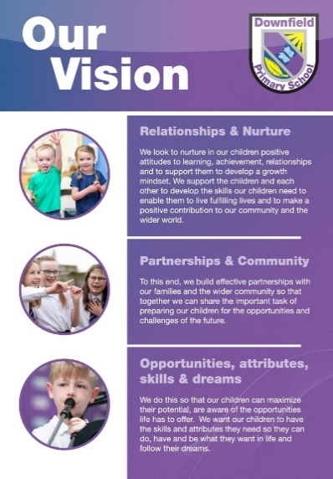
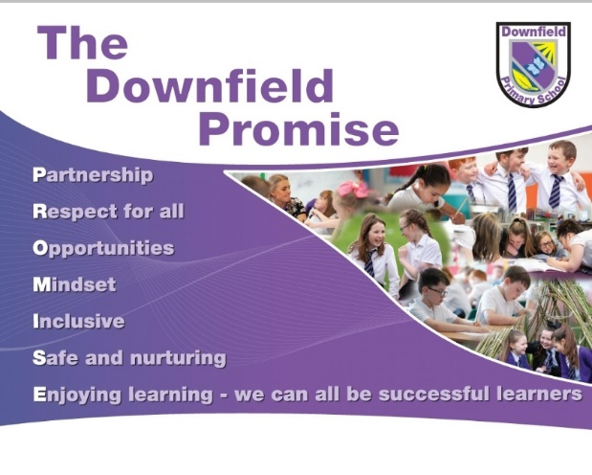

Improvement planning priorities:
The EEF Guide to Supporting School Planning: A Tiered Approach, 2020-21 pulls together previous research to provide a guide to support school leaders with their planning for this academic year. It proposes a tiered approach to prioritising efforts and honing existing plans, geared around:
1. high-quality teaching for all, revisit and revise pedagogy High Impact Teaching Strategies
2. targeted academic support - Nurturing approaches, interventions that work Lit/Num/Soc – 1:1 tutoring, Fresh Start, Wave 3, Wasps/Hornets,
3. wider strategies to support pupils in the year ahead – widen universal nurture approaches, consistent 6 and visualised environment, invest time in developing digital skills for all – pupils, parents, staff

