Our Values & Aims  Downfield Primary School is a values based learning community where we take a pride in developing all aspects of children’s learning. We do not wish to focus only on academic achievement but also recognise and celebrate all aspects of our children’s development and success. We have a number of pupil groups in our school where pupils plan collaboratively with staff to take decisions on learning and the life of our school and put creative learning and pupil voice at the heart of what we do.  We as a school community will make a promise to each other to support each other to help and nurture our children to be the best they can be, make good choices and develop the skills they need to do well as they make their way in the world.  Values: The Downfield Promise  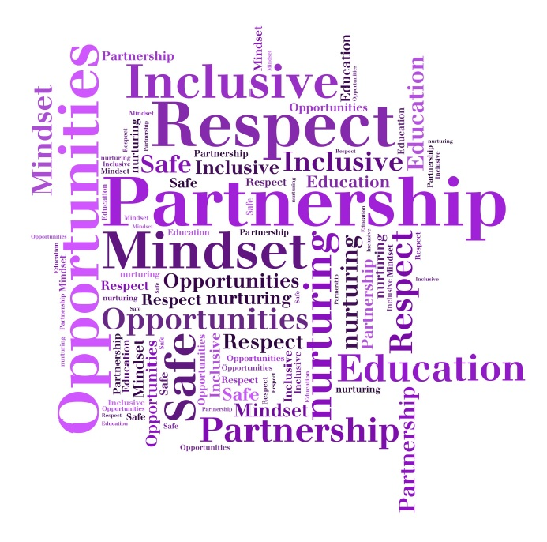  - Partnership  - Respect for all  - Opportunities  - Mindset  - Inclusive  - Safe and nurturing  - Enjoying learning- we can all be successful learners |  |  |  |  | Our School: Vision, Values & Aims  DOWNFIELD PRIMARY SCHOOL  - DUNDEE CITY COUNCIL
A warm welcome….  Downfield Primary School takes a pride in developing all aspects of children’s learning. We are committed to promoting positive attitudes and providing children with opportunities to ‘make a difference’.  We look to foster in our children positive attitudes to work, achievement, self-esteem and the wider world whilst supporting the children to develop the skills to be successful learners, confident individuals, effective contributors and responsible citizens.  To this end, we build effective partnerships with you and the wider community so that together we can share the important task of preparing our children for the opportunities and challenges of the future, so that they can achieve their full potential and follow their dreams. We want our pupils to be able to do, have and be what they wish and follow their aspirations when they leave school and make a positive difference in whatever path they choose.  We value an ethos which supports all children to develop and  improve their skills for life, learning and work within a supportive learning environment. We strive to offer experiences that allow our children to be creative, imaginative and thoughtful, encouraging everyone to give their best effort and treat others with kindness and respect. We expect our pupils to work hard and focus on good learning, while reinforcing the importance of what happens outside the classroom too.  We value your involvement in your child’s education and  development as a crucial part of our continuing partnership.  Please be assured that no concern about your child’s learning, care and welfare is too small or unimportant to share with us; do not hesitate to contact us at any time.  Mrs Karen Emmett  Head Teacher |  |  |  |  |  | Our Vision  Relationships & Nurture  We look to nurture in our children positive attitudes to learning, achievement, relationships and to support them to develop a growth mindset. We support the children and each other to develop the skills our children need to enable them to live fulfilling lives and to make a positive contribution to our community and the wider world.  Partnerships & Community  To this end, we build effective partnerships with our families and the wider community so that together we can share the important task of preparing our children for the opportunities and challenges of the future.  Opportunities, attributes, skills & dreams  We do this so that our children can maximize their potential, are aware of the opportunities life has to offer. We want our children to have the skills and attributes they need so they can do, have and be what they want in life and follow their dreams.

