# **Downfield Primary School Newsletter**

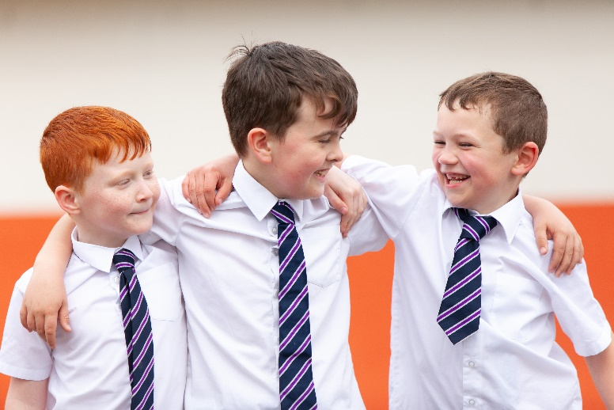

**Safer Streets – coming to our school soon!**

The School Streets Scheme (effectively a vehicle exclusion zone around the school) is planned to begin later next year. It will take effect at the beginning and end of the school day.  It would create a pedestrian and cycle only zone on the streets that currently experience high volume of traffic (Haldane Cresc). The restrictions would be in place at 8:30am - 9:15am and 3:00pm - 3:30pm. It looks likely that the scheme will begin here in second half of next year – probably August onwards. This scheme has already been in place at Fintry PS since September and has made the area around their school safer at these busy times. It will create a safer area for our pupils and families and encourage environmentally friendly methods of travel to and from school. Access to the street during these times will be strictly prohibited, with the exception of residents with permits and blue badge holders. More info to follow in streets in the run up to the implementation and I have invited Euan Mackay, from sustainable transport dept at Dundee City Council to come along to explain the scheme at our next parent council meeting.

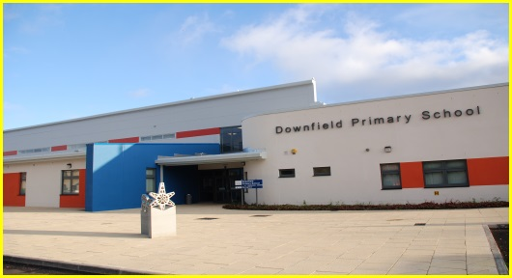

|  |  |  |
| --- | --- | --- |
| [Type the company name] | [Pick the date] | [Edition 1, Volume 1] |

***November/December 2021***

*What a busy term! Lots going on as always and I have to say that the children have been working hard with their learning. There is a lovely focused feel to the school at the moment and my attainment meetings with staff are showing that progress is being made in key areas. We discuss every child and it is always lovely to hear the great work going on across the school. I am excetionally proud of my teachers, support team, early years team and support for learning staff. They are all truly amazing. I would like to take this opportunity to thank parents for their ongoing efforts in supporting the school . We are reintroducing home work tasks this school session and hope to support parents with this.*

**Parent Council**  - Downfield Parent Partnership

The PP met earlier this week to discuss a varied agenda. We welcomed Wanda Milne – our new PP Vice chair to her first meeting in her new role. A source of much debate was safety in and around or school, including parking, the recent letter regarding consultation around school crossing patrollers and the safer streets initiative (also featured on our newsletter). Our PP has asked that any parents who feel strongly about the info contained in the letter I was asked to send out to our parents and carers respond to the consultation before the middle of next week. Some of the PP put together a standard response that you could edit and send in. Please send these to the emails detailed on the message, not directly to the school. The PP hope to share with you soon the outcome of the consultation but at the meeting there was a strong feeling that they would like to maintain the school crossing patrollers at all our crossings. If you have any questions regarding the meeting or would like to be involved, please contact John Anderson McGuinness (chair), Wanda Milne (vice chair) or Louise Buist (treasurer) or any member of the PP. The PP meet next on **17 January 2022 at 6pm** in school, with an online option. Links are sent out immediately before the meeting.

*As the weather is beginning to turn colder in the coming weeks can I ask that children come to school dressed for the weather. We like the children to make the most of the outdoor time and will only bring them indoors if the weather is really wild. A cosy jacket and shoes for the weather*

*means their outdoor time is more enjoyable – nothing worse than being cold and miserable! Currently we bring the P1 children in 15 mins early at 1pm for some indoor fun during the winter months. They will enjoy the full lunch hour again when the milder weather returns.*

**Christmas Events in our School:**

Unfortunately, schools are still not able to throw open the doors to our families to share learning or all things Christmas with you all! However – we do have a plan! We have arranged a Christmas year group party for each child. No cost at all to parents – we will provide all the party food, games, fun etc. and children can come in their party clothes or bring a change with them that day. Please note that we are unable to take any food donations from home. We have a Christmas lunch day planned for WEDS 15th DECEMBER in our lunch hall. We are allowing small gifts for staff (we realise children are always keen to do this). A small box will be kept in each classroom and staff will direct children to leave them there, where the gifts will be quarantined for 72 hours and then staff will be able to take them home. We are hoping to make a short singalong video of all the children which will be shared with families before we break up. Feel free to show this to family members! Anyone without social media permissions won’t be able to take part – our school office may phone you to check if you wish your child to be included if you’ve indicated you don’t want your child in school photos, media etc. A picture containing clipart, vector graphics

|  |
| --- |
|  |
|  |

Email : [Downfield.primary@dundeecity.gov.uk](mailto:Downfield.primary@dundeecity.gov.uk) or **follow us on twitter:** twitter.com/downfieldps Find us on Facebook too!

**Our Christmas party days are as follows:**

**January**

Term 3 begins **Thursday 6th January 2022**

* **17th Parent Partnership Meeting**

|  |  |  |
| --- | --- | --- |
|  | *Dates coming up – tear this off and keep!* |  |

**P1 Friday 17th December**

**P2 Monday 20th December**

**P3 Tuesday 21st December**

**P4 Tuesday 14th December**

**December**

* **2nd – P1 Height and Weight Checks**
* **3rd – Dress down day (bring a raffle prize with you if you can – to be used by parent council for hampers)**
* **Week beginning 13th – Interim reports**
* **13th P1&P2 – Dental Checks**
* **15th – Christmas Lunch**
* **22nd – End of term 12pm finish**

**P5 Tuesday 14th december**

**P6 Monday 20th December**

**P7 Monday 20th december**

**Please remember that party snacks and drinks will be supplied by the school. Please let class teachers know of any allergies you wish us to be aware of.**

**SCHOOL MEALS –**

**Please note that FREE SCHOOL MEALS entitlement increases from January 2022 to include all pupils up to and including our P5 children. It will be further extended to P6 and P7 Later on in the year.**

**Have a Merry Christmas when it comes! Mrs E 😊**