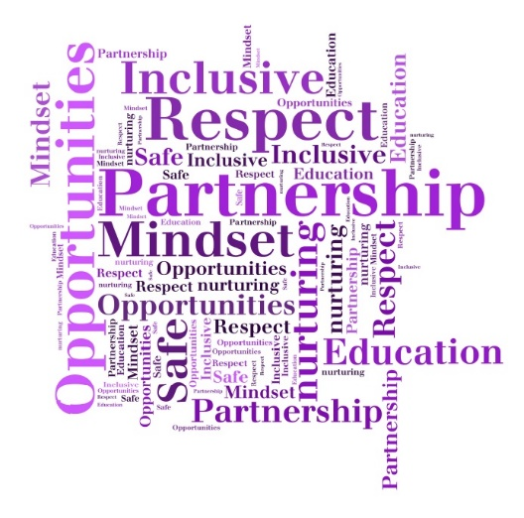****

**The Downfield Promise**

**P**artnership

**R**espect for all

**O**pportunities

**M**indset

**I**nclusive

**S**afe and nurturing

**E**ducation: Excellent learners

**1. Daily Meet and Greet**

**2. Kind Words**

-no shouting, good manners

**3. Respectful Actions**

- holding doors, good listening, caring for our learning environment

**1. Yellow Letters**

**2. Recognition Boards**

**3. Star of the Week/ Hot Choc Friday**

**4. Happy Heart Chart**

**5. Phone call Home**

**6. Dojo Messages**

**7. Golden Listener**

**8. House Points (max 5)**

**1. Fantastic Walking**

-in lines, left side, quietly

**2. There, Ready and on time**

- Line up when bell goes, classes collected quickly

**3. First attention to those doing the right thing**

**1. Reminder of Expectations**

- Ready, respectful, safe

**2. Private Caution**

-think carefully, make a good choice

**3. Final Opportunity**

-30 second script, good choice

**4. Time Out**

- think/move/other class

**5. Letters**

-Pink/Blue/Call home if necessary

**6. Repair/Fix**

**Relentless Routines**

**Scripts and Mantras**

**Restorative Questions**

**1. Be Ready**

**2. Be Kind and Respectful**

**3. Be Safe**

**1. Fly by…**

**2. I’ve noticed you are….**

**3. It’s ….. rule that you’ve broken…**

**4. Do you remember last week when you (add positive memory)?**

**5. That is who I need to see now.**

**6. Thanks for listening**

**1. What happened?**

**2. What were you thinking at the time?**

**3. What have you thought since?**

**4. How did this make people feel?**

**5. Who has been affected?**

**6. How have they been affected?**

**7. What should we do to put things right?**

**8. How can we do things differently in the future?**

**3 Rules**

**Recognition**

**Stepped Boundaries**

**Consistencies**