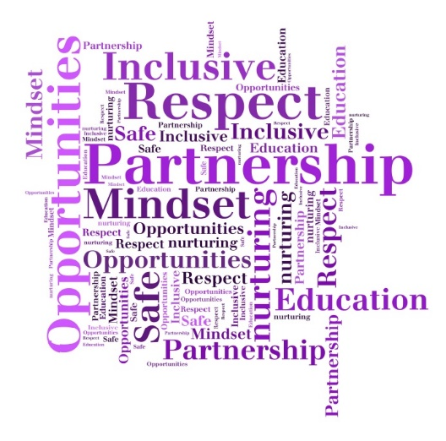****

**Differentiated Teaching Approaches**

* Inclusive relationships-based culture reflective of our school Vision, Values and Aims - PROMISE
* Appropriate support, pace and challenge to hold interest & maximise participation
* ABLe planning to minimise barriers to learning
* Differentiated approaches & effective feedback
* Good practice checklist
* [External Link](http://dmlink.dundeecity.gov.uk/WebRep/CeRDMSGetNodeContent/OTgetNode.php?node=6ea3a7a1569963a29b02)   'Dundee Good Practice Checklist.docx'
* Environmental adaptations

**The Downfield Promise**

**P**artnership

**R**espect for all

**O**pportunities

**M**indset

**I**nclusive

**S**afe and nurturing

**E**ducation: Successful learners

* Daily/Weekly with partners
* Long term forward plans created collegiately
* Annual learning overview
* Assessment planned as part of learning process – formative, diagnostic and summative
* Tracking & progression pathways
* ASN/ABLe planning
* Moderation through collaborative processes
* Conceptual understanding approaches
* Reciprocal and reflective teaching
* Making learning visible
* Learning cycle – new learning =more direct teaching, deepening/consolidation/ application of learning = more collaborative approaches
* Focus on for ‘sharing the learning’ and approaches with parents/carers in many ways

**Feedback**

In our school, feedback:

* Relates/links to SC/LI & children’s own targets
* Makes use of ‘Live/in the moment’ marking approaches
* Our ‘marking code’ is used and understood by both adults and children
* Good feedback is *detailed* (not just tick/cross), compares to previous learning & explains HOW to improve
* Is framed positively
* Uses plenaries and questioning to recap
* Focuses on *peer* feedback and self-reflection on learning tasks
* Children are taught HOW to give constructive feedback to peers
* Weekly review – ‘Feedback Friday’ or as and when targets are achieved or partly achieved by pupils

**Questioning**

* *Plan* key HOTS questions using the school BLOOMS framework
* HOTS – will provide differentiation and challenge thinking
* BE clear
* Carefully selected Qs should decrease teacher talk and increase child talk: 80/20 aspiration
* Give THINKING TIME – good answers take thought
* Listen – leave silence and space for children to respond
* Beware of using too many closed Qs – lower level Blooms
* Goals and Targets must be realistic but challenging!
* They are S M A R T
* Clear and effective Learning Intentions LI and Success Criteria SC support good feedback on achievement of targets. We involve the children with this!
* We show what SUCCESS looks like – visual examples, use VISUALISER
* We review regularly – have a class system in place.
* We link children’s targets to their everyday learning.
* Recognise and celebrate when targets are achieved
* FEEDBACK FRIDAY – can support target review and reflect.

**Setting Goals & Targets**

Differentiation is PLANNED in a variety of ways such as:

* Chilli Challenges, range of resources & use of manipulatives/visuals, level of teacher & peer support, SC/LI
* Use of planned QUESTIONS – HOTS
* High expectations for all
* Fluid groups so kids don’t get ‘stuck’, promotes choice, personalisation, motivation
* Provides support, challenge and inclusion.
* Open ended/holistic tasks
* Prior learning and assessment are key
* differentiated approaches are highly effective!
* ABLe Framework

**Planning Learning**

**Learning Approaches**

**Inclusive Pedagogy**