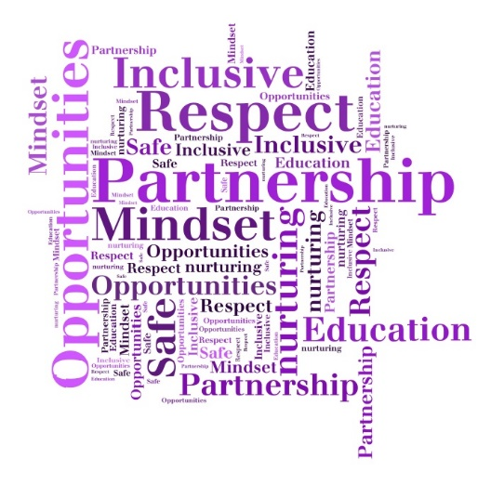

Differentiated Teaching Approaches
- Inclusive relationships-based culture reflective of our school Vision, Values and Aims - PROMISE
- Appropriate support, pace and challenge to hold interest & maximise participation
- ABLe planning to minimise barriers to learning
- Differentiated approaches & effective feedback
- Good practice checklist
- External Link 'Dundee Good Practice Checklist.docx'
- Environmental adaptations
The Downfield Promise
Partnership
Respect for all
Opportunities
Mindset
Inclusive
Safe and nurturing
Education: Successful learners

- Daily/Weekly with partners
- Long term forward plans created collegiately
- Annual learning overview
- Assessment planned as part of learning process – formative, diagnostic and summative
- Tracking & progression pathways
- ASN/ABLe planning
- Moderation through collaborative processes
- Conceptual understanding approaches
- Reciprocal and reflective teaching
- Making learning visible
- Learning cycle – new learning =more direct teaching, deepening/consolidation/ application of learning = more collaborative approaches
- Focus on for ‘sharing the learning’ and approaches with parents/carers in many ways
Feedback
In our school, feedback:
- Relates/links to SC/LI & children’s own targets
- Makes use of ‘Live/in the moment’ marking approaches
- Our ‘marking code’ is used and understood by both adults and children
- Good feedback is detailed (not just tick/cross), compares to previous learning & explains HOW to improve
- Is framed positively
- Uses plenaries and questioning to recap
- Focuses on peer feedback and self-reflection on learning tasks
- Children are taught HOW to give constructive feedback to peers
- Weekly review – ‘Feedback Friday’ or as and when targets are achieved or partly achieved by pupils

Questioning
- Plan key HOTS questions using the school BLOOMS framework
- HOTS – will provide differentiation and challenge thinking
- BE clear
- Carefully selected Qs should decrease teacher talk and increase child talk: 80/20 aspiration
- Give THINKING TIME – good answers take thought
- Listen – leave silence and space for children to respond
- Beware of using too many closed Qs – lower level Blooms

- Goals and Targets must be realistic but challenging!
- They are S M A R T
- Clear and effective Learning Intentions LI and Success Criteria SC support good feedback on achievement of targets. We involve the children with this!
- We show what SUCCESS looks like – visual examples, use VISUALISER
- We review regularly – have a class system in place.
- We link children’s targets to their everyday learning.
- Recognise and celebrate when targets are achieved
- FEEDBACK FRIDAY – can support target review and reflect.
Setting Goals & Targets
Differentiation is PLANNED in a variety of ways such as:
- Chilli Challenges, range of resources & use of manipulatives/visuals, level of teacher & peer support, SC/LI
- Use of planned QUESTIONS – HOTS
- High expectations for all
- Fluid groups so kids don’t get ‘stuck’, promotes choice, personalisation, motivation
- Provides support, challenge and inclusion.
- Open ended/holistic tasks
- Prior learning and assessment are key
- differentiated approaches are highly effective!
- ABLe Framework

Planning Learning
Learning Approaches
Inclusive Pedagogy

